# 

**Temenos Software Services**

**Cloud Change Request**

|  |  |
| --- | --- |
| Client/Project Name: | **CLCU** |
| Client CR Reference: | **CR_Account_v1.0** |
| Developed By: | **Banktech Software Services Ltd** |
| Temenos CR Reference: |  |

# Document Modification History

|  |  |  |  |
| --- | --- | --- | --- |
| **Rev.** | **Date** | **Author** | **Description** |
| 1.0 | 2021-05-31 | Nirmal Kumar N & Poorani R | First version |
| 1.0 | 2021-05-31 | Bharathi Raja Ponmudi | Reviewed & Baselined |

# Change Request Summary

|  |  |
| --- | --- |
| Initial Account Package Development as per CSD - Accounts V1.3 |  |

# Table of Contents

Document Modification History 2

Change Request Summary 2

Table of Contents 3

1. Introduction 5

1.1. Purpose of the document 5

1.2. Reference Documents 5

1.3. Sensitive Data 5

2. Requirement Name 1 6

2.1. Description 6

2.2. Assumptions / Exclusions 6

2.3. Existing Functionality 6

2.4. New Functionality 6

2.5. Customization Required 6

2.5.1. Application 6

2.5.2. Local Reference Field 6

2.5.3. Menu 6

2.5.4. Version 6

2.5.5. Enquiry 6

2.5.6. Batch 6

2.5.7. Parameterisation 7

2.6. Coding Required 7

2.6.1. Routine Name 1 7

2.7. Test Results 7

3. Requirement Name 2 7

3.1. Description 7

3.2. Assumptions / Exclusions 7

3.3. Existing Functionality 7

3.4. New Functionality 7

3.5. Customization Required 7

3.5.1. Application 7

3.5.2. Local Reference Field 7

3.5.3. Menu 7

3.5.4. Version 7

3.5.5. Enquiry 8

3.5.6. Batch 8

3.5.7. Parameterisation 8

3.6. Coding Required 8

3.6.1. Routine Name 1 8

3.7. Test Results 8

4. Requirement Name 3 8

4.1. Description 8

4.2. Assumptions / Exclusions 8

4.3. Existing Functionality 8

4.4. New Functionality 8

4.5. Customization Required 8

4.5.1. Application 9

4.5.2. Local Reference Field 9

4.5.3. Menu 9

4.5.4. Version 9

4.5.5. Enquiry 9

4.5.6. Batch 9

4.5.7. Parameterisation 9

4.6. Coding Required 9

4.6.1. Routine Name 1 9

4.7. Test Results 9

5. Deliverables 9

5.1. BUILD.CONTROL 10

5.2. JAVA 10

6. For Temenos Use Only 11

6.1. Review Results 11

# Introduction

## Purpose of the document

The purpose of this document is to highlight changes made to CLCU when AD and Account document signed off.

This is initial package in regards to Account product setup and configuration for CLCU. Related Screens are removed from menu items, rename and adding new account to the menu.

## Reference Documents

The following documents are delivered as part of this change request.

|  |  |  |
| --- | --- | --- |
| **File Name** | **Author** | **Description** |
| RTM_CLCU_Accounts.xlsx | Bharathi Raja Ponmudi | Requirements Traceability Matrix |
| Test_Cases_Result v1.0_CLCU_Account | Bharathi Raja Ponmudi | Test Cases |
| TSS Installation Guide v1.0_CLCU_Account | Bharathi Raja Ponmudi | Installation Guide |
| Order of Package - CLCU_Account.xlsx | Bharathi Raja Ponmudi | Order of Package |

## Sensitive Data

This section contains information about the new data elements introduced by this change (application, local reference field) that could potentially identify a customer, account or any other sensitive personal detail. This information will be used in the data anonymization process when a copy of a production database needs to be taken off site.

|  |  |  |
| --- | --- | --- |
| **Application** | **Field** | **Description** |
|  |  |  |
|  |  |  |

# Requirement Name 1

## Description

Account member product setup & configuration.

## Assumptions / Exclusions

N/A.

## Existing Functionality

N/A

## New Functionality

N/A

## Customization Required

This section gives the complete customization information required to achieve the functionality.

### Application

Details furnished in IG section:- 3.4 (Data Records included within CLCU001-ACCOUNT.DATA.RECS)

### Local Reference Field

N/A.

### Menu

N/A.

### Version

N/A.

### Enquiry

N/A.

### Batch

N/A.

### Parameterisation

N/A.

## Coding Required

N/A

### Routine Name 1

## Test Results

Details furnished in TCR as per RTM.

# Deliverables

Package information are shared in tdzclcuiedevft storage account. Below screen shots for reference.

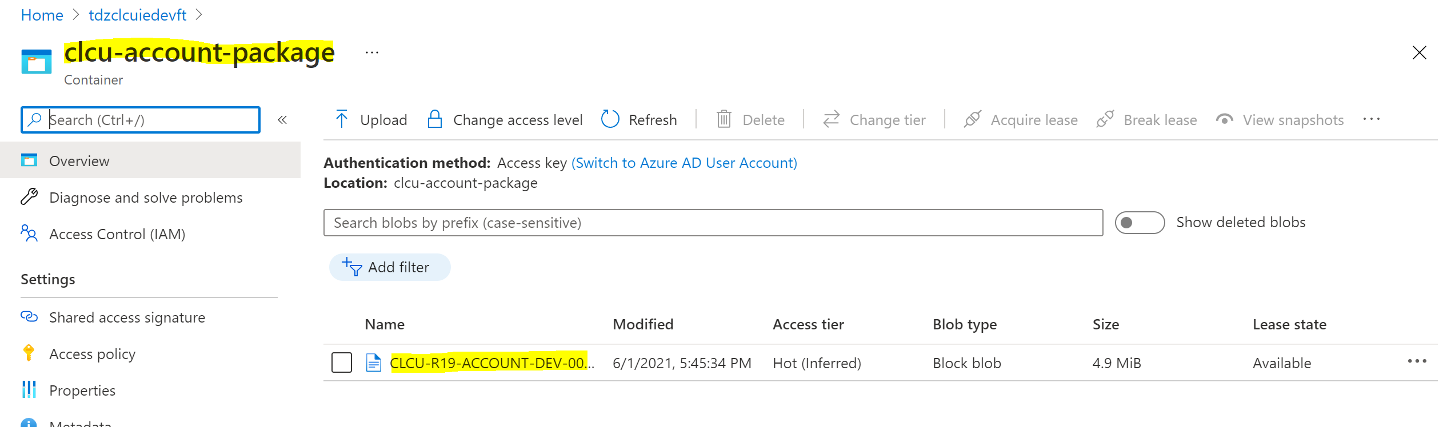

## BUILD.CONTROL

This section lists all the BUILD.CONTROL/DL.DEFINE packages delivered as part of this change request.

|  |  |
| --- | --- |
| **File Name** | **Description** |
| CLCU001-ACCOUNT.LT.PACK.zip | BCON package for LT requirement |
| CLCU001-ACCOUNT.DATA.RECORD.zip | BCON package for Data requirement |

## JAVA

This section lists the JAVA libraries delivered as part of this change request.

|  |  |
| --- | --- |
| **File Name** | **Description** |
| Cu.Account.jar | Ireland Specific package. |

# For Temenos Use Only

|  |  |
| --- | --- |
| **Date Received** |  |
| **Date Reviewed** |  |
| **Review Status** |  |
| **RTC Updated** |  |

## Review Results

|  |  |  |
| --- | --- | --- |
| **Object** | **Status** | **Review Comment** |
|  |  |  |